**SECP 1513: Technology Information System**  
Semester 01, 2024/2025

**PROJECT PROPOSAL**

**CAFÉ ORDERING SYSTEM**

**Team Name:** TECH IT EASY

**Team Members:**

1. SYAZWINA MARSYA BINTI SHAHRIZAN (A24CS0196)

2. SITI MAISARAH BINTI AHMAD ARZMY (A24CS0190)

3. RUJITHRAA NAIR (A24CS0181)

4. OSAMA HAMOOD (A22EC4025)

5. MOMEN ELGASIM MOHAMED (A24CS0021)

**Client Name:**

1. CAFE AR RAYYAN

# Table of Contents

|  |  |  |  |
| --- | --- | --- | --- |
| **Item** | **Page No** | **Prepared by** | **Moderated by** |
| 1. Introduction | 4 | Syazwina Marsya | Syazwina Marsya |
| 1. Existing Systems | 5 | Siti Maisarah | Siti Maisarah  Momen Elgasim |
| 1. Proposed System | 6 | Rujithraa | Rujithraa  Osama Hamood |
| 1. References | 7 | Syazwina Marsya | Syazwina Marsya |
| 1. Project Schedule | 8 | Syazwina Marsya | Syazwina Marsya |

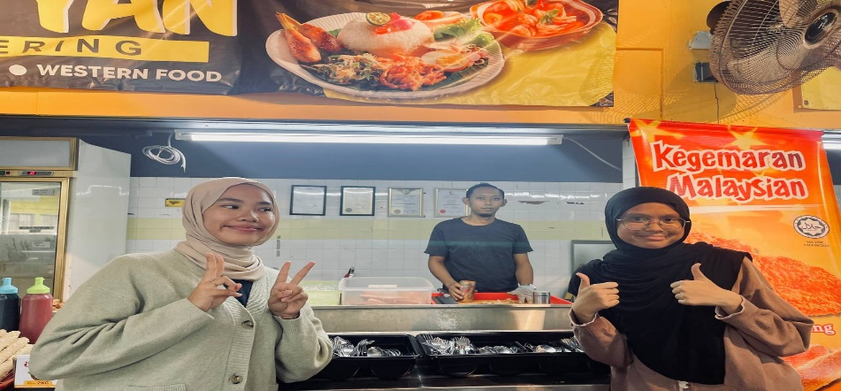

Figure Interview the client

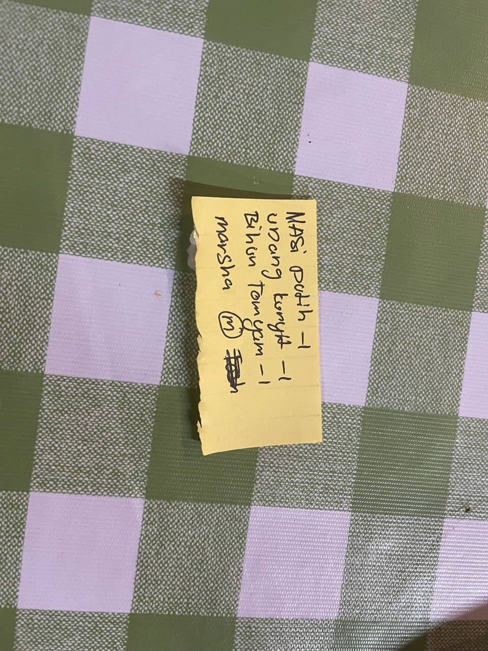

Figure Pen and paper ordering system

1. **Introduction**

|  |  |
| --- | --- |
| Need (N) | Cafe Ar Rayyan currently relies on a traditional pen-and-paper ordering system, which results in inefficiencies such as order tracking issues, manual errors, and unable to analyze sales trends or customer preferences effectively. Additionally, there is no centralized stock monitoring system, leading to situations where customers’ desired menu items are unavailable due to insufficient ingredients. These limitations prevent the cafe’s ability to provide a smooth experience for customer and optimize operational performance. A digital solution is urgently required to streamline these processes and enable data driven decision-making. |
| Approach (A) | The solution is a mobile ordering app tailored for our client. This app will include customer features such as an intuitive interface to browse the menu, customize orders, track order status in real-time, and provide feedback. Multiple payment options (e.g., cash, card, digital wallets) will ensure convenience. Admin features will include a real-time order management system, stock monitoring tools, and analytics dashboards with visualizations (e.g., bar and pie charts) to track sales trends, high-performing dishes, and underperforming menu items. The staff will also support dynamic menu updates and pricing adjustments. Additionally, backend functionality will include a centralized database to log all orders, track customer preferences, and manage inventory levels, with real-time notifications alerting staff about low stock or peak hours. |
| Benefit (B) | The app will provide several significant advantages. It will automate order tracking and stock monitoring, reducing errors and streamlining operations, while real-time updates and a user-friendly design will enhance the ordering experience for customers. Sales analytics and complete lists of stock tracking will empower the cafe to optimize the menu and reduce waste, and minimizing manual cash handling errors will ensure financial accuracy, especially during peak hours. Furthermore, the app’s modern, tech-enabled approach will give the cafe a competitive edge in a crowded market. |
| Competitor (C) | Existing solutions such as generic point-of-sale (POS) systems and standalone ordering platforms are available in the market. For instance, popular POS systems like Store Hub [1] that offer a lot of benefits such as real-time data and reporting but they lacks of profit and loss function and doesn’t provide 24/7 support. Another example is Gloria Food [2], which provides free online ordering solutions but does not integrate analytics or stock management tools. These systems fail to address specific challenges like real-time sales insights, customized menu features, and comprehensive inventory tracking. The proposed app differentiates itself by addressing these gaps, offering a tailored, cost-effective solution that meets the unique needs of our client. |

*List the URL in the references (see Section 6) and cite here when stating the systems. The details of existing solutions or systems should be elaborated in Section 2 not here. References to other documents, books or related online resources must be properly cited in the text, written here as examples [1] and GitHub [2]. Provide at least three references (see Section 6) and cite accordingly.* ***Organize the contents in paragraphs.***

1. **Existing Systems**

Our client currently operates using traditional pen and paper system of taking orders, managing inventories and customer interaction. This system involves staff taking orders manually by writing them down and pass it to the kitchen. Once the orders are complete, the staff will track the order status manually and communicates with the customer which can lead to multiple errors and delays. Since all of the order trackings are fully reliance on handwritten, thus there is no real time visibility about the status of the stock making it less optimize.

Furthermore, there is no centralized digital system to monitor their stock and manage the ingredients. Due to the lack of real time data will cause the staff to be unaware of the stock level until the customer orders it. This will lead to customer dissatisfaction and also missed sale opportunity

Table 1: Comparison of existing systems

|  |  |  |
| --- | --- | --- |
| Features | Pen-and-Paper System | Proposed Ordering App |
| Order Management | Orders are handwritten that can cause errors | Orders are automatically recorded and tracked in real time ensuring work efficiency |
| Stock Management | Stock is managed manually through physical check at the end of the day | Real time stock monitor and automatically alert when it’s low stock or high demand items |
| Sales | No system for tracking sales and customers preference. Decisions are made by assumptions | The app include analytic dashboard, highlight customer preference and |
| Financial Accuracy | Cash handled manually which is prone to error, especially during peak hours | Automated payment processing and money tracking ensure accuracy and reduce errors |
| Customer Experience | Customers place orders without knowing the order status and longer waiting time | Customers can track their order status in real time and reduce wait time |
|  |  |  |

1. **Proposed System**

**We proposed an interactive page, that includes features that cater to the client’s business such that :-**

**i) User-Friendly Dashboard**:

* **Food Catering :** The dashboard will display a list of dishes catered to students and residents of Kolej Tun Dr. Ismail. This will help the café staff to minimize the chances of miscommunication between customers and staff.
* **Frequently Ordered Dishes :** A section on the dashboard will highlight the most frequently ordered dishes. This can help the staffs identify popular items and ensure they are well-stocked, potentially boosting operating hours and customer satisfaction.
* **Real-Time Updates :** Ensures the café staffs to reflect and work on new orders as they come in.
* **Order History :** Allow regular customers to reorder their favourite dishes. Allow café staffs to identify and analyse customers’ preference and strike out dishes that are less popular. This helps in reducing food waste and increase kitchen efficiency.
* **Customizable Orders :** Allows customers to customize their orders based on their preferences that include food portion, options to remove or add ingredients and avoid ingredients that may cause reactions to customers with allergies.

**ii) Payment Options :** Multiple payment options such as Mobile Payment(Apple Pay), E-Wallets(Touch ‘n Go),Online Payment(MAE) and cash are acceptable to cater to customer preferences and enhance dining experience.

**iii) Customer Feedback** : Allows customers to rate their experience, valuable insights and suggest improvements.

**iii) Mobile-Friendly Interface :**

**We also proposed to have an application with features below :-**

* **Notifications :** Keep users informed with updates and latest food dishes and promotions.
* **Offline mode :** Allow users to access to certain features even without Internet connection
* **Security Measures :** Protect user data and ensure the availability of the application and its services

1. **References**
2. Low, D. (2025, January 8). *3 Best POS System for Malaysian in 2025 (Cloud vs Traditional POS, POS Integration, Web Host Consideration)*. Bitcatcha - Online Presence DIY. <https://www.bitcatcha.com/my/pos-system/>

[2] Chatgpt. (n.d.). <https://chatgpt.com/>

[3] R. Adithya, A. Singh, S. Pathan and V. Kanade, (2017). Online food ordering system.  
International Journal of Computer Applications [Online]. Available:  
<https://doi.org/10.5120/ijca2017916046>

**Appendices**

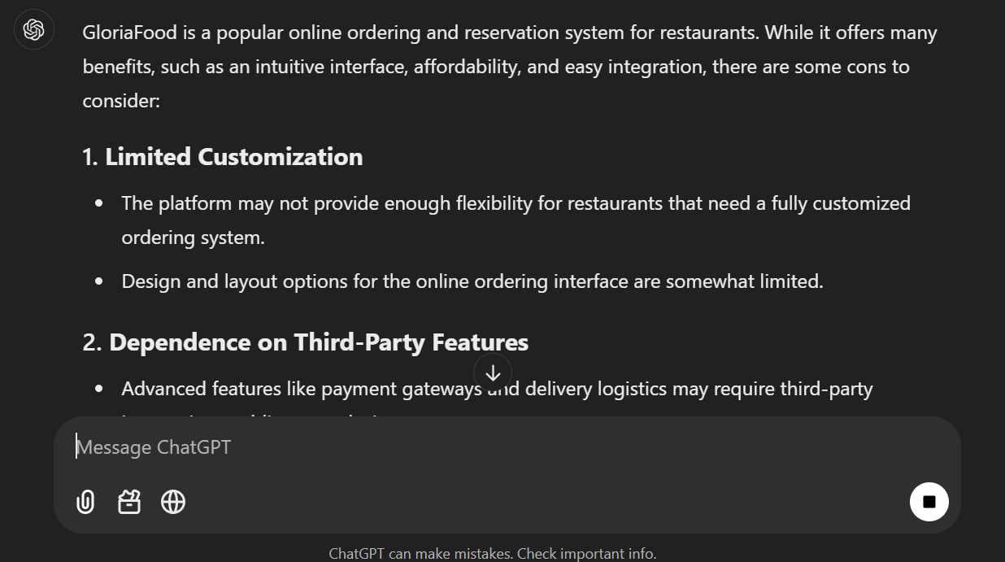  
   
[2] [**https://chatgpt.com/c/677e4016-f5bc-800a-a251-f3d31b1ef65a**](https://chatgpt.com/c/677e4016-f5bc-800a-a251-f3d31b1ef65a)

**Project Schedule**

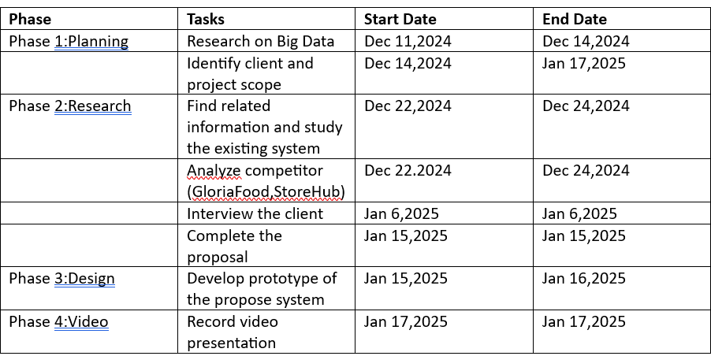

|  |  |
| --- | --- |
| ***Marking Criteria*** | *Marks* |
| *Introduction*   * *Needs* * *Approach* * *Benefits* * *Competitors* | *12 marks* |
| *Existing Systems* | *4 marks* |
| *Issues or problem with existing systems* | *4 marks* |
| *Proposed System* | *10 marks* |
| *Project Schedule* | *5 marks* |
| *References* | *2 marks* |
| *Overall report quality* | *3 marks* |
| *Report Total marks* | *40 marks* |